Linux Server :- Server Security and automation

- Install the OpenSSH server package on your Linux system and verify that the sshd service is running by connecting to localhost using the ssh command.
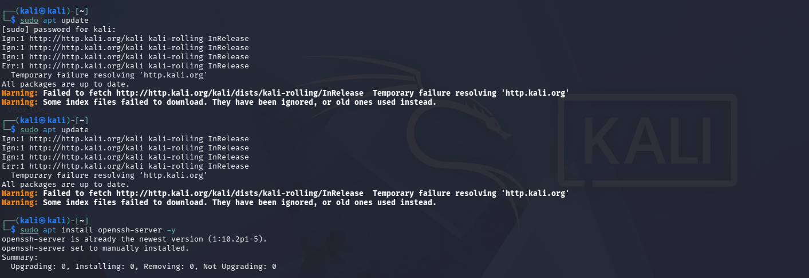
Step 1: Install OpenSSH Server
Step 2: Start and Verify the SSH Service
And

Step 3: Test SSH Connection to Localhost

- Generate a new SSH key pair using ssh-keygen, and add your public key to the ~/.ssh/authorized_keys file of your user account to enable key-based authentication.
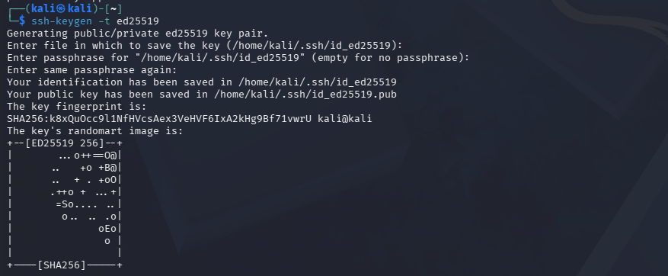
Step 4: Generate an SSH Key Pair
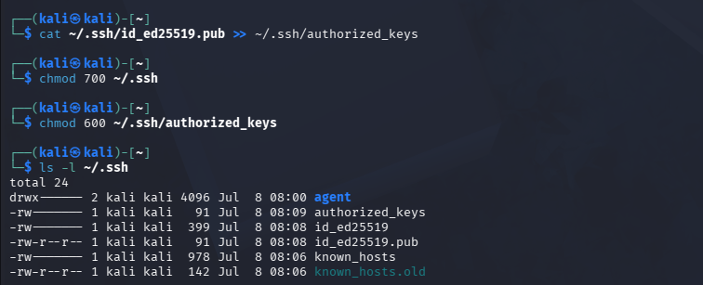
Step 5: Configure Key-Based Authentication

Step 6: Test SSH Key Authenticatio
3.Edit the /etc/ssh/sshd_config file to disable password authentication by setting PasswordAuthentication no, then restart the sshd service and test that you can only log in using your SSH key.
Step 7: Disable Password Authentication
Open the SSH server configuration file.

Find the following line:
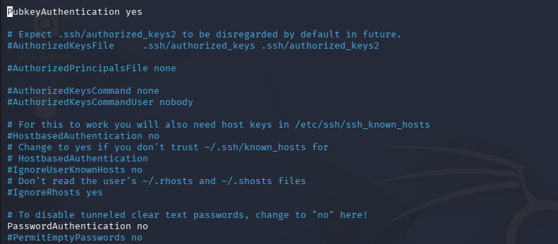
Uncomment both files 1. PasswordAuthentication yes or 2. PubkeyAuthentication yes

Step 8: Restart the SSH Service
Step 9: Verify That Password Authentication Is Disabled
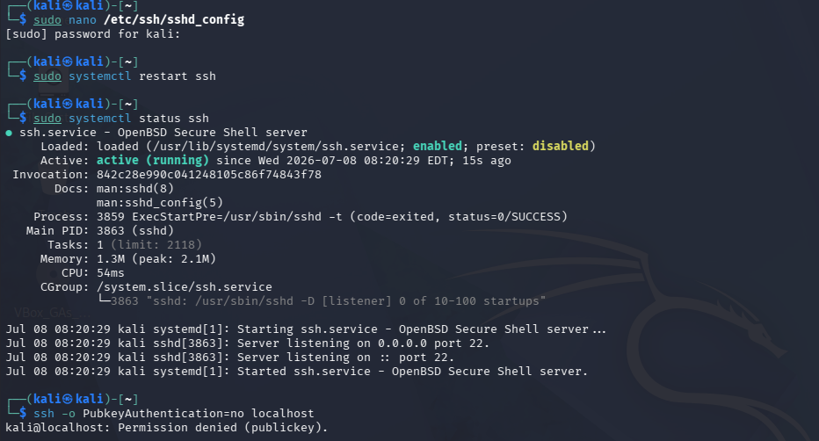
Conclusion
SSH key-based authentication was successfully configured on the Kali Linux system. Password authentication was disabled, improving the security of the SSH server. The configuration was verified through successful key-based login and failed password-based authentication.

